Drop Foot And How Bracing Can Help

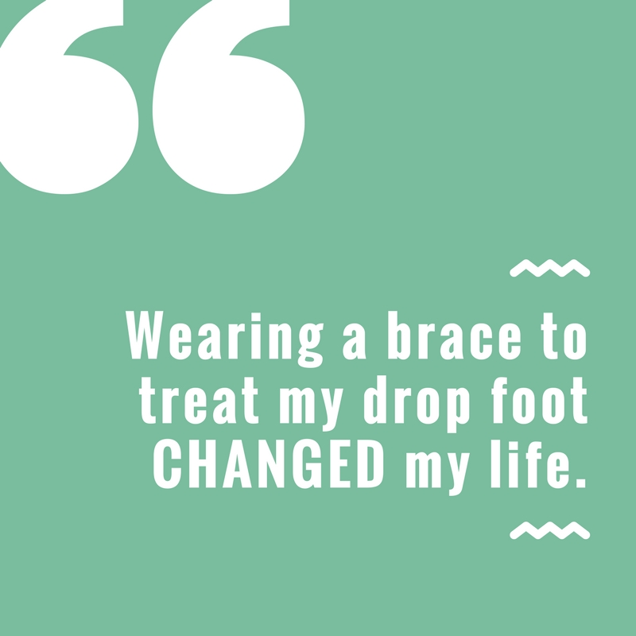
Do you suffer from drop foot? Drop foot is not a medical condition in itself, but a symptom of a cluster of different issues.
It is a general problem lifting the front of the foot; thus, if you suffer from drop foot, your leg may drag behind you as you walk.
It is a sign of an underlying condition, such as a neurological, anatomical or muscular condition. This causes an unusual gait, which can cause further problems, such as numbness, from the foot dragging on the ground as you walk. It sounds like a simple problem, but it involves a significant weakness of ankle and toe dorsiflexion, which is often caused by nerve issues and illnesses such as diabetes and muscular dystrophy.
WHAT CAN CAUSE DROP FOOT?
It can be caused or exacerbated by kneeling for extended periods, leg crossing or wearing a leg cast that causes weakness in the foot.
Drop foot is fairly common among stroke victims and the elderly, but I have also seen some patients that that are young develop it because of a pinched nerve behind the knee. It can even be induced by exercise!
The first step is an appointment with your podiatrist. If you have drop foot, you’ve likely undergone some type of imaging procedure, like x-rays, CAT scans or MRIs to determine the cause. Electromyography is another method of testing nerve function.
Once your doctor has determined the cause of your drop foot, ankle braces are a good treatment option (possibly with other treatments to help with the underlying condition, if needed). For example, if the cause of the drop foot is habitual leg crossing, this will remedy itself within several months, whereas nerve damage has a more complicated treatment plan.
HOW CAN BRACING HELP?
Regardless of cause, ankle foot orthosis (AFO) braces are the usual treatment for the symptoms. The purpose of the brace is to help promote normal gait and keep the foot from dragging on the ground, thus helping individuals with drop foot live a more active life.
A dorsiflexion foot brace can support the ankle and with a spring action, assist you to lift your foot.
Regardless of the cause of your foot drop, bracing can be an effective tool to manage symptoms and help patients lead a more active lifestyle. Your doctor can help determine what brace is most effective for you individually.
In addition to bracing, there may be special exercises to improve your condition. In some cases, surgery may be necessary, but by preventing the foot from dragging on the ground, and creating a more normal gait, bracing is an effective way to improve posture and quality of life.
If you want to be better in your everyday life, make an online appointment with Lexington Podiatry or call (859) 264 – 1141 today!

